Task 15

Q1. Difference between selenium ide, Selenium Web driver, Selenium Grid.

|  |  |  |
| --- | --- | --- |
| Selenium IDE | Selenium Web Driver | Selenium Grid |
| Its primarily Record and run tool. For testcase Development.  Here we do not write any test Scripts.  Its needs the extension for the browser to run the test cases.  It accepts the Selenius command. The command can convert in to many programming languages.  Selenium Ide is used only for Firefox Driver.  Selenius can converted into many programming Languages (JAVA, Phython,C#,etc) | Its a Web Framework that allows to do the Cross Browser testing.  Here Write the test Scripts in many programming Languages.  Selenium WebDriver can intract with web browser using WebDriver interface. | It’s a Smart proxy Browser that makes it easy to run tests in parallel machines.  Here we use two components called Hub, Node  Hub routes the  Test commends that is in JSON format to multiple Grid Nodes.it takes instruction from client and executes them remotely on the various nodes in parallel.  Node is a remote that consist of a native OS and a remote WebDriver its receive commends from Json format and executes parallelly. |

Q2.

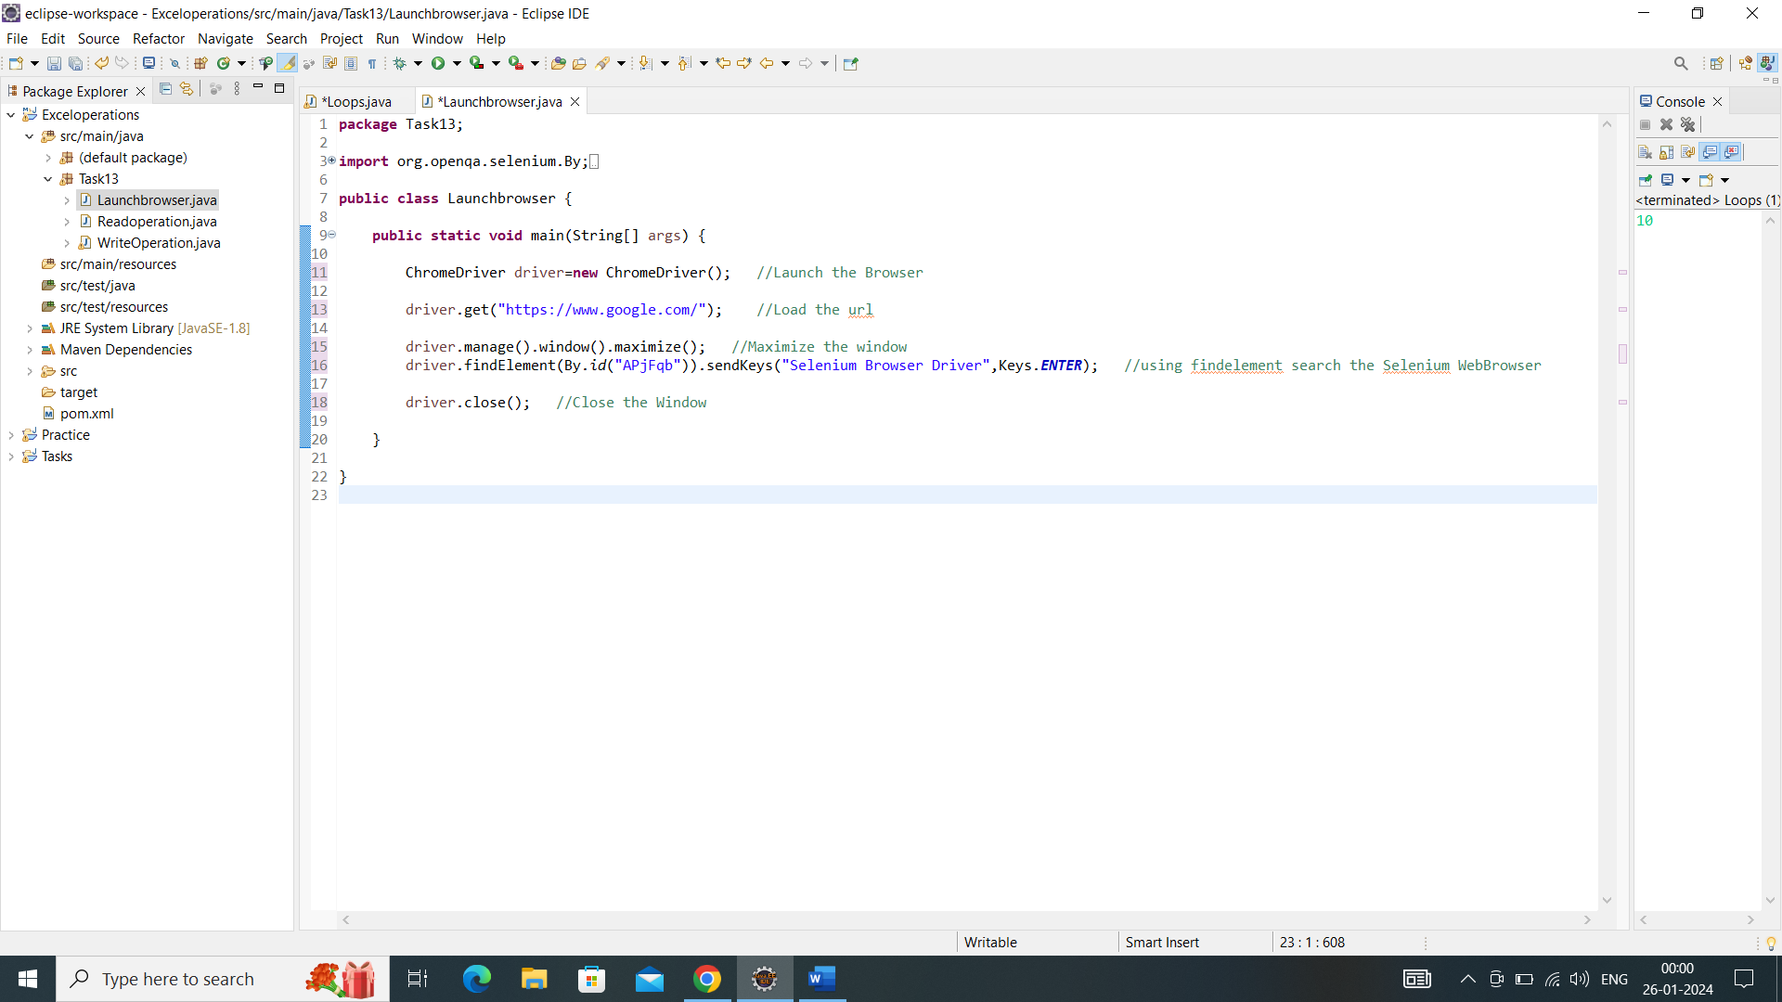

Output:

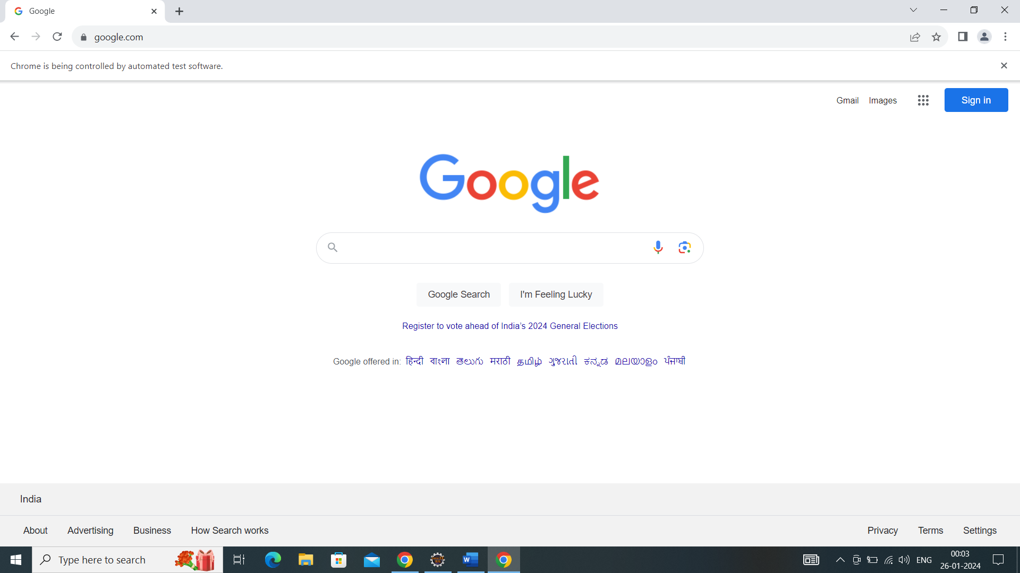

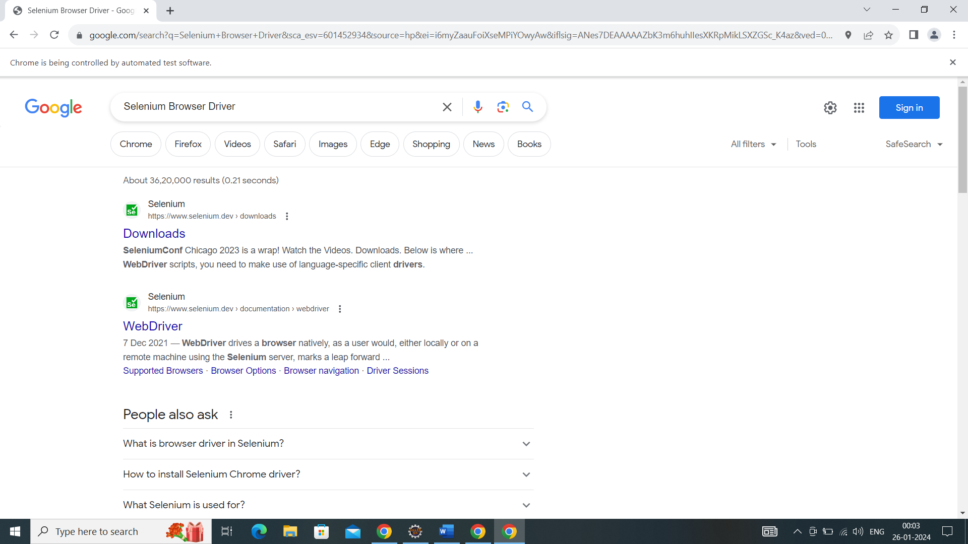

Q3.

Selenium:

* Selenium is an Automation Testing tool.
* It automates browser.
* It’s Created by Jason Huggins in 2004.
* Initially it named as a Java Script Test Runner. Later its changed as a Selenium code.

Uses in Automation testing:

* It’s very popular in the market. Its widely used because of free and open source.
* It Supports Multiple Programming Languages. (java,python,ruby etc).
* Selenium is automated web-based Application.
* Its have a large community support to get immediate response.
* Its Support cross-browser Compatibility.
* It supports Platform Compatibility.
* Its also integrated with other framework and libraries.

Q4. Browser Driver Used in Selenium:

* Chrome Driver. (For Google Chrome)
* Gecko Driver (For Mozilla Firefox)
* Microsoft Edge Driver (For Microsoft Edge)
* Safari Driver (For Safari).

Q5.

Code:

Chrome Driver driver=**new** Chrome Driver();

driver.get("https://www.google.com/");

driver.manage().window().maximize();

driver.findElement(By.*id*("APjFqb")).sendKeys("Selenium Browser Driver",Keys.***ENTER***);

driver. Close ();

1. Launch the driver using the code for Chrome Driver driver = new Chrome Driver ();
2. Then using the get method and give URL as string arguments.
3. To maximize the window as we use the code for driver reference and respective classes.
4. Then as inspect the web elements and give the code for find elements. using send key method pass the arguments as we Search. And hit the enter key command.
5. Then close the driver as we used the method close.

The output for the above code Is its launch the chrome browser and hit the URL after maximize the window. It searched the Selenium Browser Driver. Then close the window.